**Data Analyst for Retailer App Case Study**

**Objective:**

To Draw Insight for given dataset and finding answer of following question

**Q1. Which KPIs would you use to measure the performance of our app?**

* By Unique User

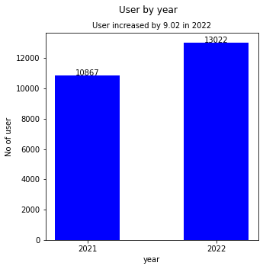

* By Average app Visit by Days

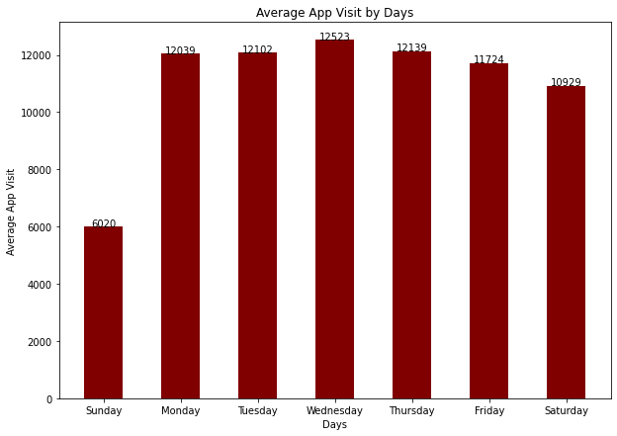

* By Sales

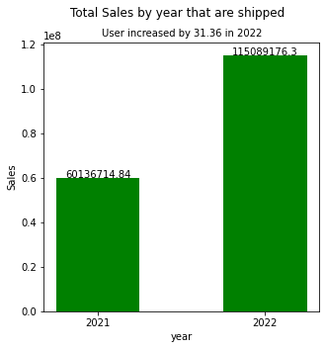

**Q2 Prepare a report regarding our growth between the 2 years. Please try to answer the following questions:**

* . Did our business grow?

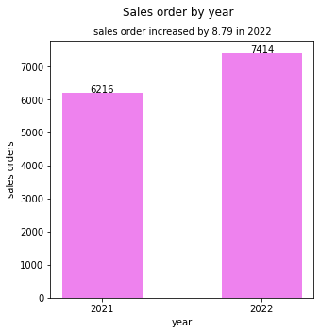

* . Does our app perform better now?

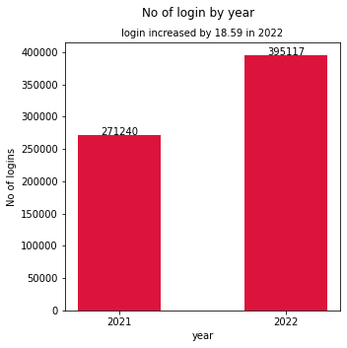

* Did our user base grow?



**Q3 What are our top-selling products in each of the two years? Can you draw some insight from this?**

* In 2021

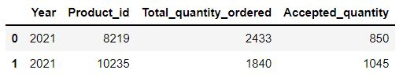

* In 2022

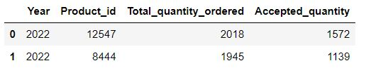

If we insure the availability of product we can reduced product orders getting rejected and can achieve maximum sells

**Q4 Looking at July 2021 data, what do you think is our biggest problem and how would you recommend fixing it?**

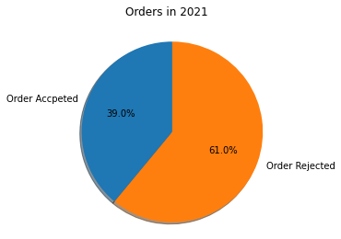

More orders are rejected as compared to those are accept

If we ensure the availability of products then only include in the product list

**Q5 Does the login frequency affect the number of orders made?**

* Yes app login increased by 18.59% in the year 2022
* Number of users increased by 9.02% in the year 2022
* And sales orders increased by 8.79 % in the year 2022